14. IMPLEMENTING DATABASE SECURITY MEASURES( e.g. USE AUTHENTICATION, ACCESS CONTROL).
-- Select database
USE test;

-- Create table
CREATE TABLE IF NOT EXISTS employees1 (
id INT AUTO_INCREMENT PRIMARY KEY,
name VARCHAR(100),
email VARCHAR(100),
salary DECIMAL(10,2)
);

-- Create users
CREATE USER IF NOT EXISTS 'readonly_users'@'localhost'
IDENTIFIED BY 'ReadOnly@123';

CREATE USER IF NOT EXISTS 'writer_users'@'localhost'
IDENTIFIED BY 'Admin@123';

CREATE USER IF NOT EXISTS 'db_admins'@'localhost'
IDENTIFIED BY 'Admin@123';

-- Read-only user: SELECT only
GRANT SELECT
ON test.*
TO 'readonly_users'@'localhost';

-- Writer user: SELECT, INSERT, UPDATE, DELETE
GRANT SELECT, INSERT, UPDATE, DELETE
ON test.*
TO 'writer_users'@'localhost';

-- Database admin: all privileges
GRANT ALL PRIVILEGES
ON test.*
TO 'db_admins'@'localhost';

-- Check privileges
SHOW GRANTS FOR 'readonly_users'@'localhost';
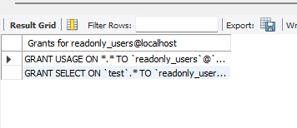
SHOW GRANTS FOR 'writer_users'@'localhost';
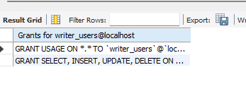
SHOW GRANTS FOR 'db_admins'@'localhost';
